**PYCOLORYMETRIC**

411221012 - Kenedi Peres

Teknik Informatika

Universitas Dian Nusantara

[411221012@mahasiswa.undira.ac.id](mailto:411221012@mahasiswa.undira.ac.id)

**ABSTRACT**

This program aims to analyze color differences between a target image and a printed image using the RGB to CMYK color conversion method, and measuring color differences using the delta E CIE76 approach. By uploading two images for analysis, the program will then calculate the color density in the CMYK color channels and their solidity in each image. The comparison results between the target and the resulting images are displayed through image visualization, color density statistics, and graphical comparisons to facilitate the interpretation of color differences. This program can be used for in-depth analysis of print quality and image processing, especially in the printing or graphic design industry.

**Keywords:** RGB color, CMYK color, delta E CIE76, Density, Solidity, Printing, Graphic design

**CHAPTER I INTRODUCTION**

**1.1 Background**

In the world of graphic design and printing, color accuracy is one of the key factors in producing printed results that meet expectations. The printing process often faces challenges in ensuring that the colors printed on paper match the final artwork displayed on a monitor. This is due to the differences between the color models used in digital design (RGB) and the color models used in printing (CMYK). Therefore, a method is needed that can accurately analyze and compare colors between target images and resulting images to determine the extent of the differences that occur.

In addition, in the graphic design and printing process, it is important to monitor and measure color parameters such as density and color solidity. Color density describes the extent of the color intensity in an image, while solidity measures how consistent or varied the distribution of that color is. Both of these factors are very important for determining the quality and uniformity of print results.

With this background, this program was developed to provide a solution in analyzing color differences using RGB to CMYK conversion and measuring color density and solidity. This program is expected to facilitate professionals in the fields of printing, graphic design, and digital image processing to evaluate color quality more objectively and in depth.

**CHAPTER II**

**RESULTS AND DISCUSSION**

**2.1 Understanding Color**

Color is a visual element that has a significant influence on human life. It is not only about beauty, but also has its own meaning, emotion, and appeal. In general, a color can be seen from different perceptions in each person. Some people like certain colors, while others do not like some colors.

Translation of the KBBI definition:

According to the Great Indonesian Dictionary (KBBI), color is the impression obtained by the eye from the light reflected by objects, thus forming a color pattern such as blue and green. Color is a specific spectrum that exists within a perfect white light. The identity of this color is determined by the wavelength of light.

**2.2 Understanding RGB Color System**

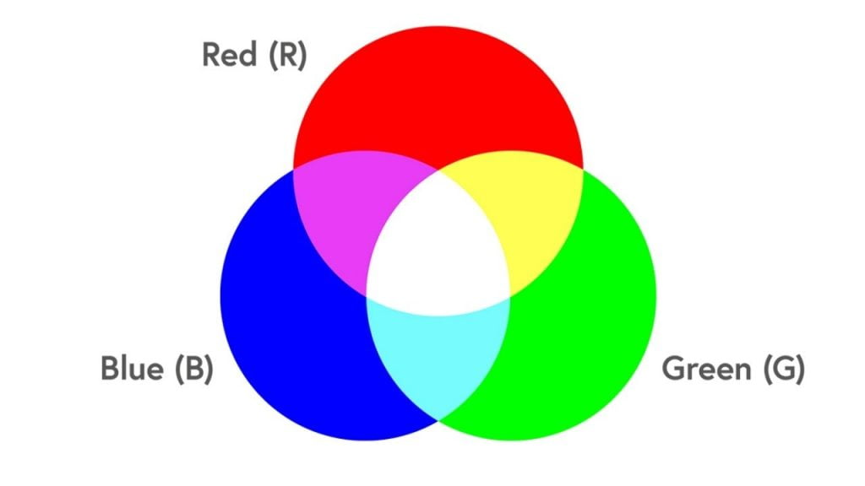

**Image 1.** *Visual representation of RGB colors*

RGB color stands for Red, Green, Blue. RGB is an additive color system used to produce colors on computer monitors, televisions, and other digital devices. The basic concept behind the RGB color system is that when these three primary colors are combined in varying intensities, they can create a wide spectrum of colors. Each color in the RGB system is represented by a combination of the intensity of red, green, and blue. Each color component has an intensity range from 0 to 255. An intensity of 0 represents the absence of color, and 255 represents the maximum intensity for that color. By adjusting the intensity of these three colors, you can produce various desired colors.

**2.3 Understanding CMYK Color System**

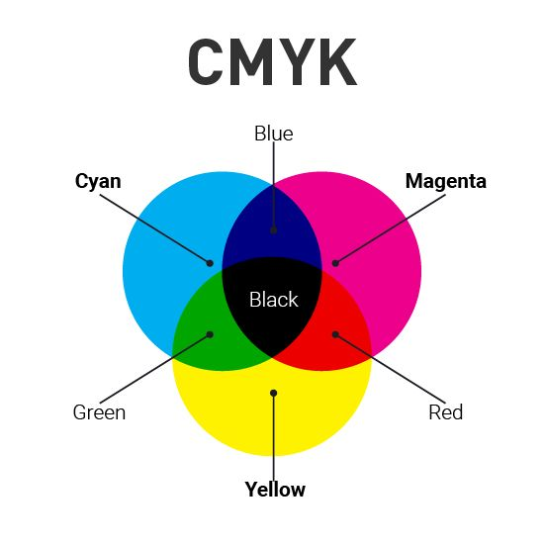

**Image 2.** *Visual representation of CMYK colors*

CMYK color is an acronym for Cyan, Magenta, Yellow, and Key (Black). The CMYK color system is a subtractive color system used in the printing industry to create colors on printed paper. The CMYK color system is based on the concept that when the three primary colors of Cyan, Magenta, and Yellow are mixed together, they will produce black. However, the result of mixing these three primary colors tends to produce a color that is too dull and not quite a solid black. Therefore, black is added as the fourth component in the CMYK color system. This black color is then known as Key (K), to increase the strength and sharpness of the color.

Each color in the CMYK color system is represented by a percentage of its ink. Cyan, Magenta, and Yellow each have their own ink box with varying percentages, which are used to mix colors. Black (Key) has its own ink box with a maximum percentage to create a strong black color. In practice, every color in a graphic design must be converted to CMYK color mode before printing. This is because colors on a computer screen or digital device may look different from colors on printed paper.

This color conversion will ensure that the printed color matches the intended color in the Final Artwork. Thus, the composition and intensity of the color in the printed result will be exactly the same as what is in the Final Artwork.

**2.4 Understanding Color Density**

A measure of the intensity of a color (cyan, magenta, yellow, black) within an image, calculated by averaging the color component values of all pixels in the image. Density is measured as a percentage, reflecting the extent to which a particular color component dominates the image. It can be used to analyze the quality and accuracy of color in printing or image processing applications. To calculate color density, the average intensity value of each color component (C, M, Y, K) across all pixels in the image is computed. This average value is then multiplied by 100% to obtain the percentage of color density using the following formula for each color component (C, M, Y, K):

Color Density = ( Average Component Value / 1 ) × 100%

**2.4 Understanding Color Solidity**

In the context of image analysis or image processing, color solidity refers to the consistency or distribution of a color's intensity within an image. Generally, color solidity describes the level of variation or diversity in the distribution of a color's value (e.g., Cyan, Magenta, Yellow, Black in the CMYK model) throughout the image. If a color has low solidity, it means that the color is distributed consistently and evenly throughout the image. Conversely, if the solidity is high, it indicates a large fluctuation or variation in color intensity in different parts of the image.

Color solidity for each color component (Cyan, Magenta, Yellow, Black) is calculated using the standard deviation of the component's values across all pixels in the image. The mathematical formula is as follows:

Color Solidity = σ (CMYK Color Percentage)

**2.6 How the PyColoryMetric Program Works**

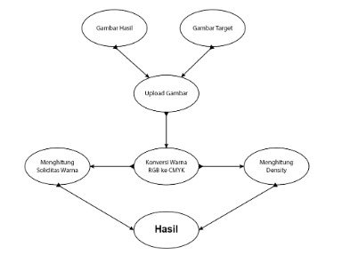

**Image 3.** *Image processing diagram*

In this research, a qualitative method was used. The study employed two images: a color target and a print result. The objective was to analyze color and compare the two images in terms of color density and color consistency (solidity) in the CMYK color channels of each image. The author named this project "PyColorymetric," which means a color measurement program using Python programming language. As the name suggests, the program was developed using Python programming language, with images processed using machine vision techniques. The steps involved in the implementation of this project include:

1. The program requests the uploading of two images: the target image and the result image.
2. The images are then converted from RGB to CMYK for further analysis.
3. Color density and solidity are calculated for each image.
4. The difference between the target image and the result image is calculated and displayed.
5. The images and their CMYK components are displayed, and a comparison graph of color density and solidity is also shown.
6. The program provides a comprehensive overview of the color quality and differences between the two images.

**2.7 Analysis Results**

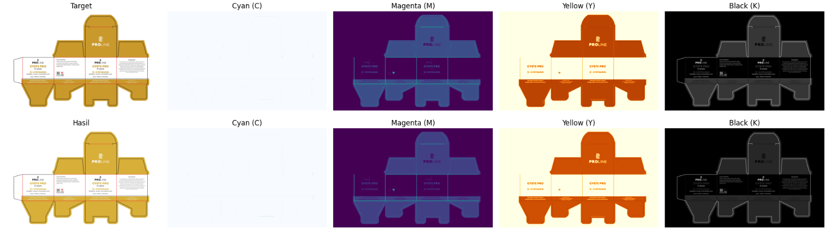

**Image 4.** *Visualization of research object by displaying color parameters*

This program processes two uploaded images, a target image and a result image, for color analysis using the CMYK model. After converting the images from RGB to CMYK, the program calculates several color parameters such as density and solidity for each color component (Cyan, Magenta, Yellow, Black).

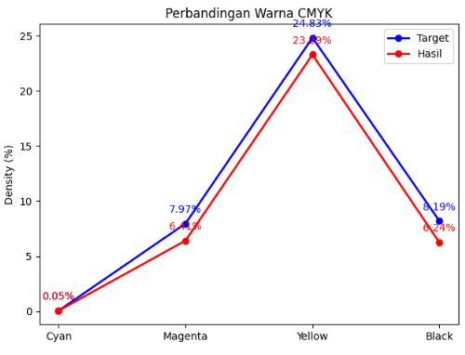

**Image 5.** *Graphical visualization*

The calculation results show differences in color density between the target and result images, with the difference values obtained for each color component visualized in bar and line graphs. The color difference calculation using deltaE indicates the level of color difference between the two images, which can provide an overview of how accurate the color reproduction is in the result image. Additionally, the program displays the images along with their CMYK channels to provide a visual representation of the color distribution in both images.

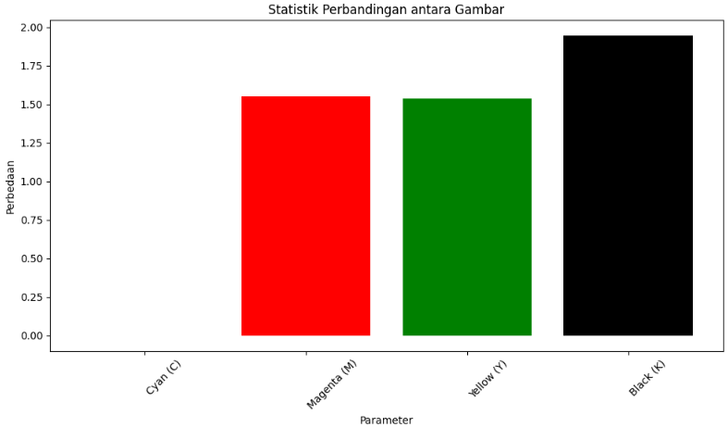

**Image 6.** *Color comparison statistics between two images*

From the analysis results, it can be seen that the density and solidity of color in some components show significant differences, which may be caused by variations in the printing process or the quality of the resulting image.

Overall, this program provides useful information for evaluating and comparing colors in the printing industry or digital image color analysis, as well as identifying potential differences between the expected image and the result image.

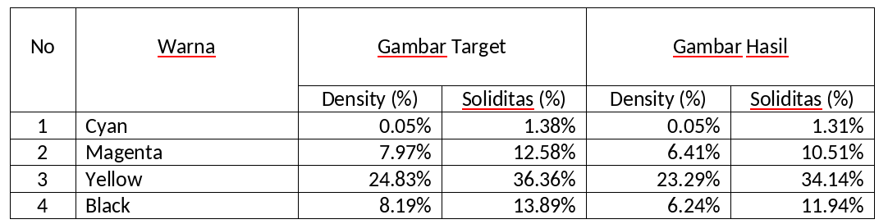

**Image 7.** *Color value table data*

Furthermore, after analysis based on the density-related table data, there is almost no significant difference between the target image and the result image, while the solidity shows a slight decrease in solidity in the result image, but still within a very close range. This indicates that the Cyan color in the result image is slightly less compared to the target image. However, overall, there is a decrease in density in the three colors, namely Magenta, Yellow, and Black, in the result image compared to the target image. This defines that these colors become slightly more faded in the result image. As for color solidity, there is also a decrease. This indicates that these colors become less vibrant in the result image.

**CHAPTER III**

**CONCLUSION**

This program analyzes the color difference between two images: a target image and a resulting image, using the CMYK color model. By converting images from RGB to CMYK, color density and solidity can be calculated for each CMYK color component. The program can calculate color difference using the deltaE method, providing an indication of how accurately the resulting image reproduces the colors of the target image. The calculated results of density and solidity differences are displayed in a graphical format, making it easier to understand the differences between the two images. Thus, this program can be used to analyze color quality in printing and other digital image processing applications.

**CHAPTER III**

**REFERENCES**

Romzi, M., & Kurniawan, B. (2020). “Pembelajaran Pemrograman Python Dengan Pendekatan Logika Algoritma” (Issue 2)

Hernando, D., Widodo, A. W., & Dewi, C. (2020). “Pemanfaatan Fitur Warna dan Fitur Tekstur untuk Klasifikasi Jenis Penggunaan Lahan pada Citra Drone” (Vol. 4, Issue 2). <http://j-ptiik.ub.ac.id>

Hucadinota, L., Amri, A., Basuki, U., & Ruliftiawan, G. (2022). “controlling color consistency in the production process of packaging print pengendalian konsistensi warna pada proses produksi cetak kemasan” (Vol. 9, Issue 1).

Widodo Budiharto, Widodo (2018). “Pemrograman Python Untuk Ilmu Komputer dan Teknik” (Vol. 4, Issue 1).

ISO 13655:2009 (2009). “Graphic Technology – Spectral Measurement and Colorimetric Data for Graphic Arts Images. International Organization for Standardization.”

Adobe Systems Incorporated. (2011). “Adobe Photoshop CS5 for Photographers: The Ultimate Workshop. Focal Press.”

Gonzalez, R. C., & Woods, R. E. (2008). Digital Image Processing. Pearson Prentice Hall. (Issue 3)

CIE (Commission Internationale de l'Éclairage). (2004). “CIE 15:2004 Colorimetry” (Vol 9, Issue 3)

X-Rite Inc. (n.d.). Understanding Color in Digital Imaging: The Basics of Color Theory and Color Management. X-Rite.

<https://www.xrite.com>

Python Software Foundation. OpenCV Documentation.

<https://docs.opencv.org>